**Sudoku solver in Prolog**

**Rakshit Sharma**

**1702913086**

**Sudoku:**

**Sudoku** is the Japanese abbreviation of a phrase meaning the digits must remain single, also known as ***Number Place***, where Su means number, doku which translates as single or bachelor.

Sudoku is not a mathematical or arithmetical puzzle. It works just as well if the numbers are substituted with letters or some other symbols, but numbers work best.

The aim of the puzzle is to enter a numerical digit from 1 through 9 in each cell of a 9×9 grid made up of 3×3 subsquares or subgrids, starting with various digits given in some cells; each row, column, and subsquares region must contain each of the numbers 1 to 9 exactly once.

Throughout this document we refer to the whole puzzle as the **grid/game board**, a 3x3 subgrid as a **block** and the individual grids that contains the number as a **cell.**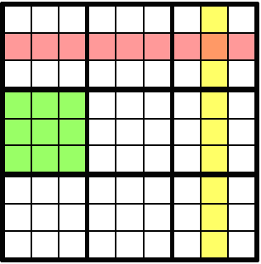 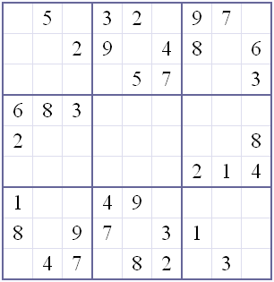Figure : Sample Sudoku game

### **Rules :**

Solving a Sudoku puzzle can be rather tricky, but the rules of the game are quite simple.

Solving a sudoku puzzle does **not** require knowledge of mathematics; simple logic suffices.

The objective of sudoku is to enter a digit from 1 through 9 in each cell, in such a way that:

1. Each horizontal **row** contains each digit exactly **once**
2. Each vertical **column** contains each digit exactly **once**
3. Each subgrid or **region** contains each digit exactly **once**

**Model Design for the application :**

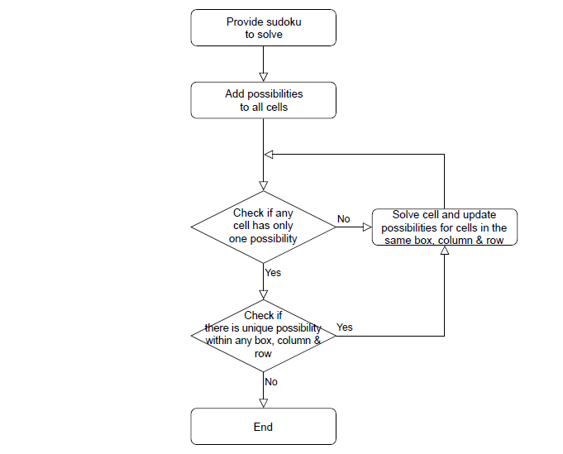

Follow this simple steps to solve a sudoku:

* Run the prolog console

$ cd <THIS_REPO>

$ swi-pl

Welcome to SWI-Prolog ....

* Define a sudoku and run the solver

[sudoku].

S = [_,_,_,2,6,_,7,_,1,

6,8,_,_,7,_,_,9,_,

1,9,_,_,_,4,5,_,_,

8,2,_,1,_,_,_,4,_,

_,_,4,6,_,2,9,_,_,

_,5,_,_,_,3,_,2,8,

_,_,9,3,_,_,_,7,4,

_,4,_,_,5,_,_,3,6,

7,_,3,_,1,8,_,_,_],

solvesudoku(S, Solution).

or run the demonstration file:

[demonstration].

test.

The output will be something like this:

?- [sudoku].

true.

?- S = [_,_,_,2,6,_,7,_,1,

| 6,8,_,_,7,_,_,9,_,

| 1,9,_,_,_,4,5,_,_,

| 8,2,_,1,_,_,_,4,_,

| _,_,4,6,_,2,9,_,_,

| _,5,_,_,_,3,_,2,8,

| _,_,9,3,_,_,_,7,4,

| _,4,_,_,5,_,_,3,6,

| 7,_,3,_,1,8,_,_,_],

| solvesudoku(S, Solution).

Solve sudoku...

Solution:

[4,3,5,2,6,9,7,8,1]

[6,8,2,5,7,1,4,9,3]

[1,9,7,8,3,4,5,6,2]

[8,2,6,1,9,5,3,4,7]

[3,7,4,6,8,2,9,1,5]

[9,5,1,7,4,3,6,2,8]

[5,1,9,3,2,6,8,7,4]

[2,4,8,9,5,7,1,3,6]

[7,6,3,4,1,8,2,5,9]

S = Solution, Solution = [4, 3, 5, 2, 6, 9, 7, 8, 1|...].

**CODE:**

**Sudoku.pl**

**:- use_module(library(clpfd)).**

**solvesudoku(Puzzle, Solution) :-**

**Solution = Puzzle,**

**Puzzle = [A1, B1, C1, D1, E1, F1, G1, H1, I1,**

**A2, B2, C2, D2, E2, F2, G2, H2, I2,**

**A3, B3, C3, D3, E3, F3, G3, H3, I3,**

**A4, B4, C4, D4, E4, F4, G4, H4, I4,**

**A5, B5, C5, D5, E5, F5, G5, H5, I5,**

**A6, B6, C6, D6, E6, F6, G6, H6, I6,**

**A7, B7, C7, D7, E7, F7, G7, H7, I7,**

**A8, B8, C8, D8, E8, F8, G8, H8, I8,**

**A9, B9, C9, D9, E9, F9, G9, H9, I9**

**],**

**writeln("Solve sudoku..."),**

**% all fields must be between 1 and 9**

**Puzzle ins 1..9,**

**% all rows must have only unique fields**

**all_different([A1, B1, C1, D1, E1, F1, G1, H1, I1]),**

**all_different([A2, B2, C2, D2, E2, F2, G2, H2, I2]),**

**all_different([A3, B3, C3, D3, E3, F3, G3, H3, I3]),**

**all_different([A4, B4, C4, D4, E4, F4, G4, H4, I4]),**

**all_different([A5, B5, C5, D5, E5, F5, G5, H5, I5]),**

**all_different([A6, B6, C6, D6, E6, F6, G6, H6, I6]),**

**all_different([A7, B7, C7, D7, E7, F7, G7, H7, I7]),**

**all_different([A8, B8, C8, D8, E8, F8, G8, H8, I8]),**

**all_different([A9, B9, C9, D9, E9, F9, G9, H9, I9]),**

**% all columns must have only unique fields**

**all_different([A1, A2, A3, A4, A5, A6, A7, A8, A9]),**

**all_different([B1, B2, B3, B4, B5, B6, B7, B8, B9]),**

**all_different([C1, C2, C3, C4, C5, C6, C7, C8, C9]),**

**all_different([D1, D2, D3, D4, D5, D6, D7, D8, D9]),**

**all_different([E1, E2, E3, E4, E5, E6, E7, E8, E9]),**

**all_different([F1, F2, F3, F4, F5, F6, F7, F8, F9]),**

**all_different([G1, G2, G3, G4, G5, G6, G7, G8, G9]),**

**all_different([H1, H2, H3, H4, H5, H6, H7, H8, H9]),**

**all_different([I1, I2, I3, I4, I5, I6, I7, I8, I9]),**

**% all squares must have only unique fields**

**all_different([A1, A2, A3, B1, B2, B3, C1, C2, C3]),**

**all_different([A4, A5, A6, B4, B5, B6, C4, C5, C6]),**

**all_different([A7, A8, A9, B7, B8, B9, C7, C8, C9]),**

**all_different([D1, D2, D3, E1, E2, E3, F1, F2, F3]),**

**all_different([D4, D5, D6, E4, E5, E6, F4, F5, F6]),**

**all_different([D7, D8, D9, E7, E8, E9, F7, F8, F9]),**

**all_different([G1, G2, G3, H1, H2, H3, I1, I2, I3]),**

**all_different([G4, G5, G6, H4, H5, H6, I4, I5, I6]),**

**all_different([G7, G8, G9, H7, H8, H9, I7, I8, I9]),**

**label(Solution), % resolve variables**

**% print out solution**

**writeln(""),**

**writeln("Solution:"),**

**writeln([A1, B1, C1, D1, E1, F1, G1, H1, I1]),**

**writeln([A2, B2, C2, D2, E2, F2, G2, H2, I2]),**

**writeln([A3, B3, C3, D3, E3, F3, G3, H3, I3]),**

**writeln([A4, B4, C4, D4, E4, F4, G4, H4, I4]),**

**writeln([A5, B5, C5, D5, E5, F5, G5, H5, I5]),**

**writeln([A6, B6, C6, D6, E6, F6, G6, H6, I6]),**

**writeln([A7, B7, C7, D7, E7, F7, G7, H7, I7]),**

**writeln([A8, B8, C8, D8, E8, F8, G8, H8, I8]),**

**writeln([A9, B9, C9, D9, E9, F9, G9, H9, I9]),**

**writeln("").**

**Demonstration.pl**

**:- [sudoku]. % include sudoku solver**

**test() :-**

**% define a sudoku to solve (_ are the unknown fields)**

**S = [9,8,_,7,_,_,6,_,_,**

**7,5,_,_,_,_,_,9,_,**

**_,_,6,_,_,_,_,_,_,**

**6,4,_,_,_,_,_,_,_,**

**_,_,9,6,_,_,_,5,_,**

**_,_,_,_,_,3,_,_,_,**

**_,_,7,9,_,_,_,8,3,**

**_,_,5,8,_,_,9,6,_,**

**_,_,_,_,2,_,_,_,1],**

**solvesudoku(S, Solution),**

**write("Raw solution: "),**

**writeln(Solution),**

**writeln("").**

OUTPUT:

Running Sudoku.pl

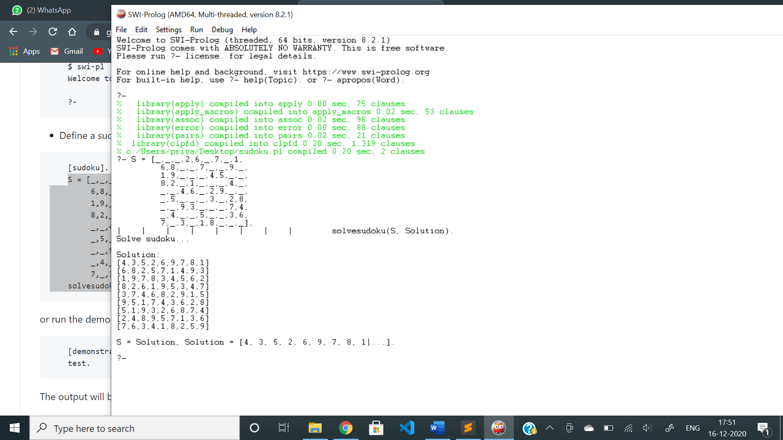

**Running Demonstration.pl**

